Type your name

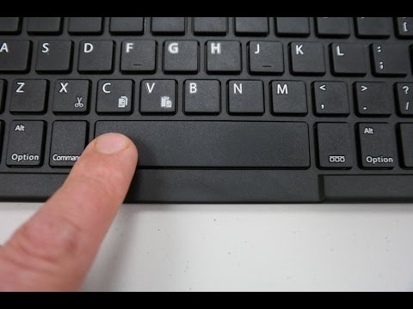
Use the spacebar

Mouse mouse mouse
Screen screen screen

Use the enter key

Enter
Enter
Enter

Keyboard
Keyboard
Keyboard

Use the backspace key

Delete this writing! | Delete this writing!

